HOHNER
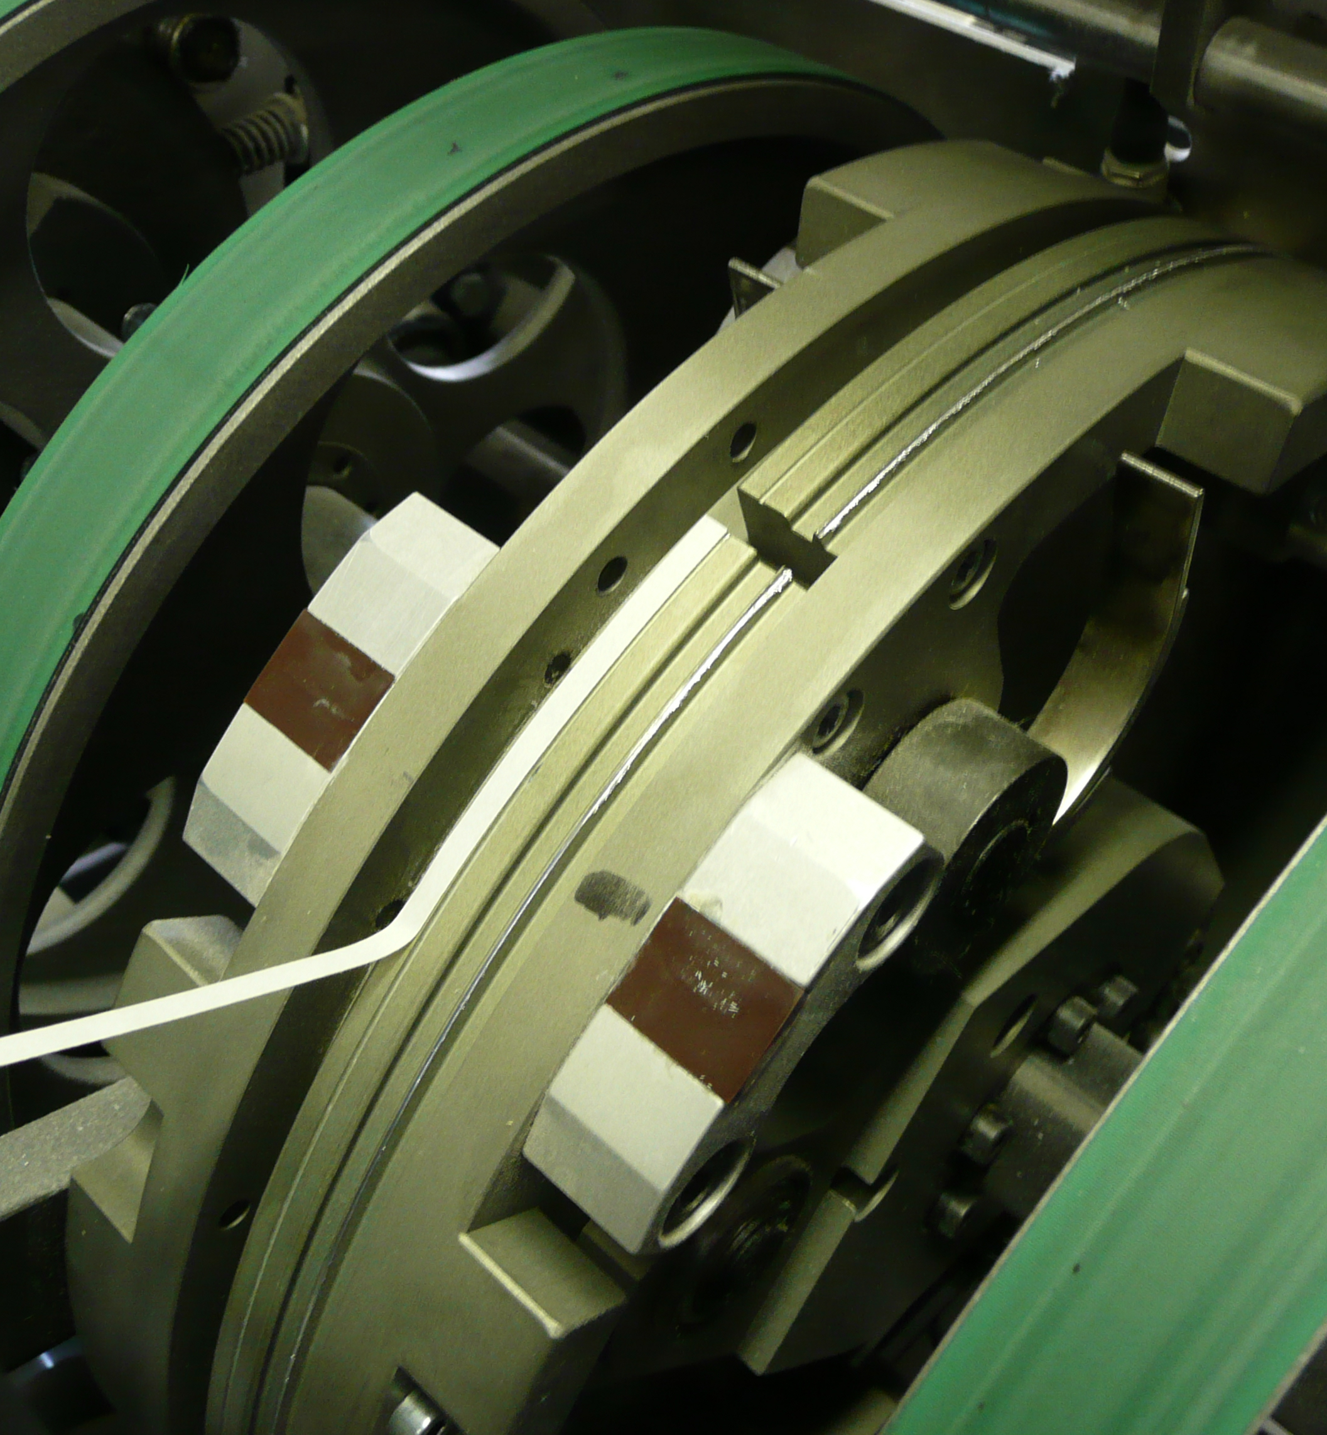
Position nylon insert into recess & push in firmly until level with the outside drum

The black creasing matrix should be positioned with a over lap of a least 25mm

